Practical- 6: Control Charts
Name: VISHVA PATEL
QUESTION-1 ---- Variable control charts

X-Bar Chart of x1, ..., x3

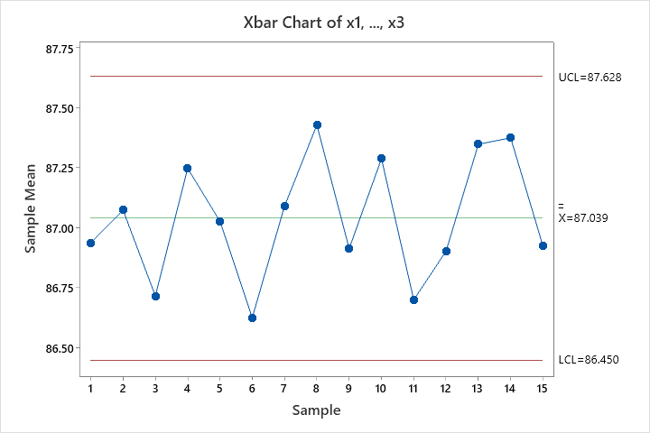

R Chart of x1, ..., x3

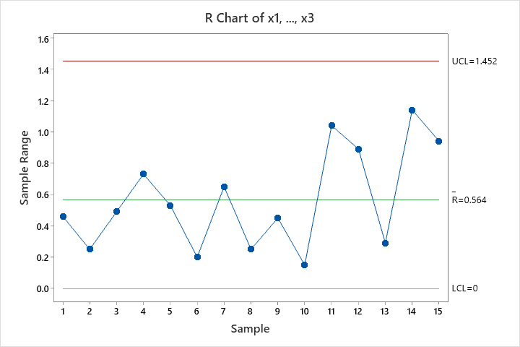

Interpretation

87 ± 0.8 |  | UCL=87.8 | LCL=86.2
Fraction of casting which will have percentage of copper within the
specification limits:
 | P(LSL<X<USL) = P (86.2< X < 87.8)

specification limit:
P(LSL<X<USL) S.D = R-bar/d2 = 0.3579
P(86.2<X<87.8)
P [(86.2-87.044)/0.3579] <z<P [(87.8-87.044)/0.3579]
P(z>-2.3582) =0.009218 (Using =Norm.S. Dist. (Z, Cumulative) Function)
p(z<2.1123) = 0.98267

- P(-2.3582<z<2.1123) = 0.99185

- If 1000 bronze casting are produced, then 991 casting will have percentage of casting within the specification limits and if 10000casting we produced then 9918 casting will have percentage of casting within the specification limits.

QUESTION-2

Data:
SAMPLE NO. | X1 | X2 | X3
1 | 0.0629 | 0.0636 | 0.0640
2 | 0.0630 | 0.0631 | 0.0622
3 | 0.0628 | 0.0631 | 0.0633
4 | 0.0634 | 0.0630 | 0.0631
5 | 0.0619 | 0.0628 | 0.0630
6 | 0.0613 | 0.0629 | 0.0634
7 | 0.0630 | 0.0639 | 0.0625
8 | 0.0628 | 0.0627 | 0.0622
9 | 0.0623 | 0.0626 | 0.0633
10 | 0.0631 | 0.0631 | 0.0633
11 | 0.0635 | 0.0630 | 0.0638
12 | 0.0623 | 0.0630 | 0.0630
13 | 0.0635 | 0.0631 | 0.0630
14 | 0.0645 | 0.0640 | 0.0631
15 | 0.0619 | 0.0644 | 0.0632
16 | 0.0631 | 0.0627 | 0.0630
17 | 0.0616 | 0.0623 | 0.0631
18 | 0.0630 | 0.0630 | 0.0626
19 | 0.0636 | 0.0631 | 0.0629
20 | 0.0640 | 0.0635 | 0.0629

MINITAB OUTPUT
X-bar Chart of X1, ..., X3

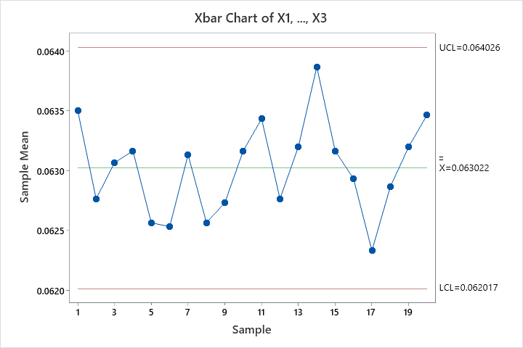

S Chart of X1, ..., X3

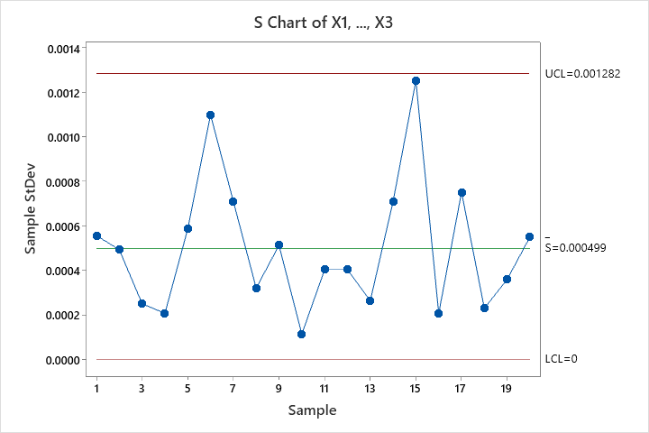

Interpretation

- Before interpreting the X-bar chart we must check process variation is under control or not. So, in our problem all the points lie between UCL and LCL, we can say that process variation is under control.

- The X-bar chart plots the average of the measurements within each subgroup. The centre line is the average of all subgroup averages. Here, data for three on board thickness, points of process mean between the Upper Control limit and lower control. So, we can say that our process is under control.

QUESTION-1 ---- Attribute control charts

Data: P-chart
Day | no of units inspected | no. of defectives
1 | 80 | 4
2 | 110 | 7
3 | 90 | 5
4 | 75 | 8
5 | 130 | 6
6 | 120 | 6
7 | 70 | 4
8 | 125 | 5
9 | 105 | 8
10 | 95 | 7

MINITAB OUTPUT
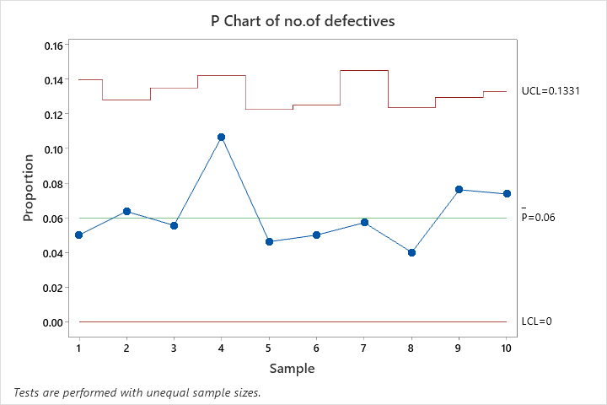

Interpretation
- The P chart plots the proportion of defective items for each subgroup. The centre line is the average proportion of defectives. All points are within the control limits, Process is under control.

QUESTION-2

Data: C-chart
SAMPLE NO. | NUMBER OF NONCONFORMITIES
1 | 2
2 | 4
3 | 3
4 | 1
5 | 0
6 | 2
7 | 1
8 | 8
9 | 2
10 | 1
11 | 3
12 | 4
13 | 1
14 | 5
15 | 2
16 | 3

MINITAB OUTPUT
C Chart of NUMBER OF NONCONFORMITIES

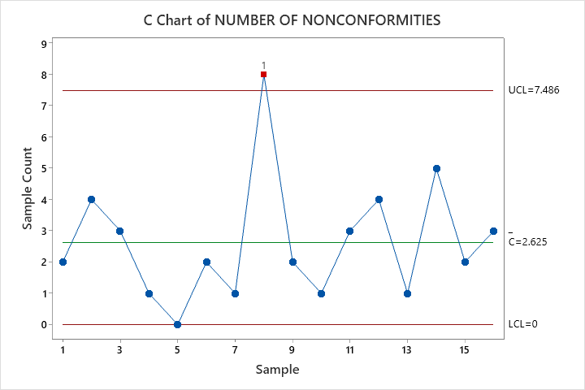

Interpretation
- One point more than 3.00 standard deviations from centre line.
Test Failed at points: 8. So, Process is not under control.

QUESTION-3

Data: U-chart

SAMPLE NO. | TOTAL NO. OF NONCONFORMITIES
1 | 10
2 | 12
3 | 8
4 | 14
5 | 10
6 | 16
7 | 11
8 | 7
9 | 10
10 | 15
11 | 9
12 | 5
13 | 7
14 | 11
15 | 12
16 | 6
17 | 8
18 | 10
19 | 7
20 | 5

MINITAB OUTPUT
U Chart of Total no. of NONCONFORMITIES

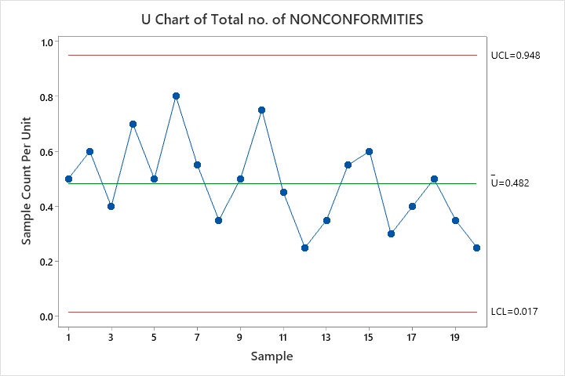

Interpretation
- This control chart monitors the average defects per unit. It plots the count of defects per unit of a subgroup as a data point. It considers the situation when the subgroup size of inspected units for which the defects would be counted is not constant. The underlying distribution of the U-chart is Poisson distribution.
- Here, in example all points lie between control limits. Process is under control.
QUESTION-4
Data: U-chart
ROLL NUMBER | TOTAL NO. OF NOCONFORMITIES | NUMBER OF SQUARE METERS
1 | 14 | 500
2 | 12 | 400
3 | 20 | 650
4 | 11 | 500
5 | 7 | 475
6 | 10 | 500
7 | 21 | 600
8 | 16 | 525
9 | 19 | 600
10 | 23 | 625

MINITAB OUTPUT

U Chart of TOTAL NO. OF NOCONFORMITIES

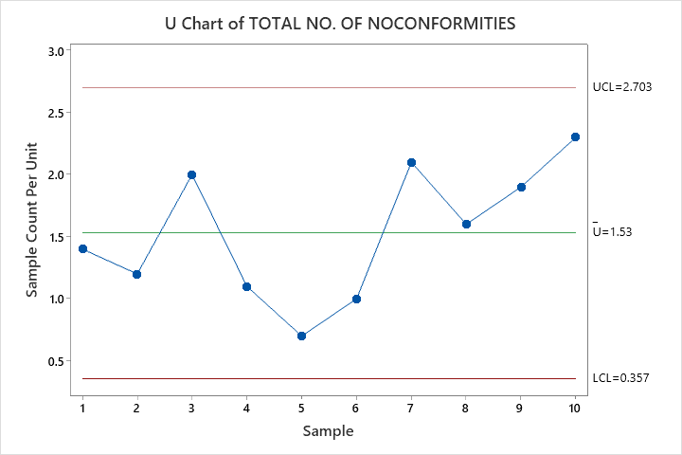

U Chart Diagnostic for NUMBER OF SQUARE METERS

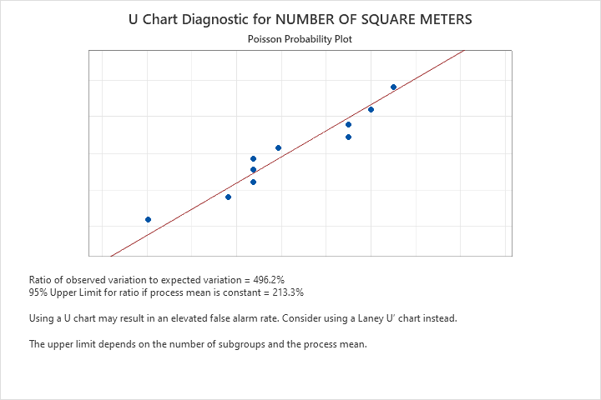

Laney U′ Chart of TOTAL NO. OF NOCONFORMITIES
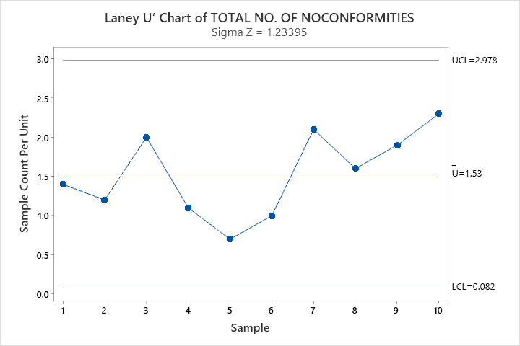

Interpretation
The Sigma Z value on a Laney U' chart indicates how much the control limits on the chart are adjusted for overdispersion or under dispersion.
- A Sigma Z value of 1 indicates that no adjustment is necessary. In this case, the control limits on a Laney U' chart are the same as the control limits on a traditional U chart.
- A Sigma Z value that is greater than 1 indicates that the control limits on the Laney U' chart are wider than the control limits on a traditional U chart to adjust for overdispersion.
- A Sigma Z value that is less than 1 indicates that the control limits on the Laney U' chart are narrower than the control limits on a traditional U chart to adjust for under dispersion.

- Here, in example Z value is 1.23 which is greater than 1. So, we can say that the control limits on Laney U’ chart are wider than the Control limits in a traditional U chart to adjust for overdispersion.

